California Scholarship Federation Member Application Form
­­­­­ Please fill out neatly by hand ­­­­­
Name (Print):

Email:

Grade Level (circle one): 9 10 11 12

Cell Phone: ( )

Instructions:
Transfer or exchange student? Check here:

- You must earn a minimum total of 10 points from last semester’s grades.
  - The total points from List I must be greater than or equal to 4 (unless you are a senior applying for membership in February or June)
  - The total points from Lists I and II must be greater than or equal to 7
  - The remaining points must come from any list (I, II, or III)
- You must use no more than 5 courses to qualify. To determine whether a class is List I, II, or III, see the following page.
- No CSF points are given for physical education, courses taken in lieu of physical education, subjects repeated to improve a grade, courses involving clerking and office/teaching assistant, and courses taken on a pass/fail basis.
- Calculate your CSF points. A grade of D or F in ANY class disqualifies you from membership.
A = 3 points AP/Honors A = 4 points
B = 1 points AP/Honors B = 2 points
C = 0 points AP/Honors C = 0 points

No more than 2 AP/Honors points may be used each semester.
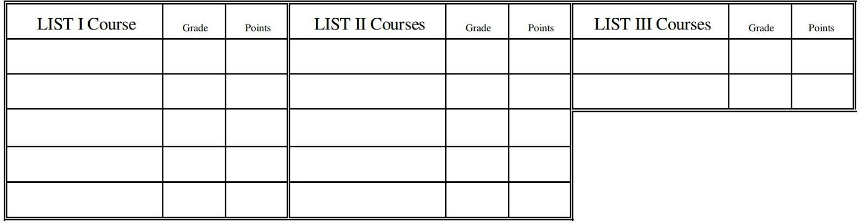

TOTAL from LIST I: | TOTAL from LISTS I AND II: | GRAND TOTAL from ALL LISTS:
(must be at least 4, except for  seniors applying in February or June) | (must be at least 7) | (must be at least 10)

- If you qualify, please bring the following to Mr. Corcoran in E-1 by the deadline.
- This application, a photocopy of last semester’s report card.
Mrs. Wickware in E13
- If your application is accepted, a $5 donation is expected to be made to the Treasurer’s Office. You will be notified prior.
- Please note that you are required to attend at least three meetings and complete your service hours by the end of the semester to remain an active member.

I authorize that the information above is true.

Applicant’s Signature Date

Sealbearers: To be a CSF sealbearer a person must have been a member in good standing four (4) out of his/her six (6) semesters, beginning with grades earned during the sophomore year. One semester must be from grades earned during the fall or spring semester of the senior year. See our website for more information.

List I
Algebra I, II
Algebra II/Trigonometry Biology (and AP) Calculus AB/BC AP
Chemistry (and Honors/AP) Economics
English I, II, III, IV (and Honors/AP) Environmental Science AP
European History AP
French I, II, III, IV AP, V Honors Geometry
Marine Biology Microeconomics AP Physics (AP/Honors) Physiology
Pre­Calculus (and Honors) Spanish I, II, III, IV AP, V Honors Statistics (and AP)
Trigonometry/Advanced Math Topics
U.S. Government (and AP)
U.S. History (and AP) World History

List II
Art History AP
Astronomy
Computer Science AP Creative Writing
Geology
Journalism I, Advanced Music Theory AP Psychology (and AP) Sociology

List III
Art I, II, Advanced
Art and Animation ROP Art Design (and Advanced) Auto I
Automotive Technology ROP Biomedical Innovation Ceramics I, II, Advanced
Civil Engineering and Architecture Computer Graphic Arts ROP
Computer Integrated Manufacturing ROP Concert Choir

List III (continued)
Developmental Psychology of Children ROP Digital Arts/Designs for the Web ROP Drama I, II, III
English Language Development Film Study Intro, Advanced Foods I, II
Game Design ROP
Guitar Beginning, Advanced Health Science
Human Body Systems Introduction to Business Finance
Introduction to Engineering Design Introduction to Environmental Science Jazz Band
Leadership (ASB and Renaissance) Marching Band/Rally Band Medical Interventions
Nutrition and Food Science Orchestra
Personal Finance Photo I, Advanced
Photography Arts I, Advanced Principles of Biomedical Science Principles of Engineering
Public Speaking I, II Show Choir
Sports Medicine ROP (and Advanced) Studio Art AP
Symphonic Band
Treble Choir/Women’s Ensemble Video Production I, II, III
Web Page Design ROP Wind Ensemble
Woodworking Technology I, Advanced Work Experience Education
Yearbook

